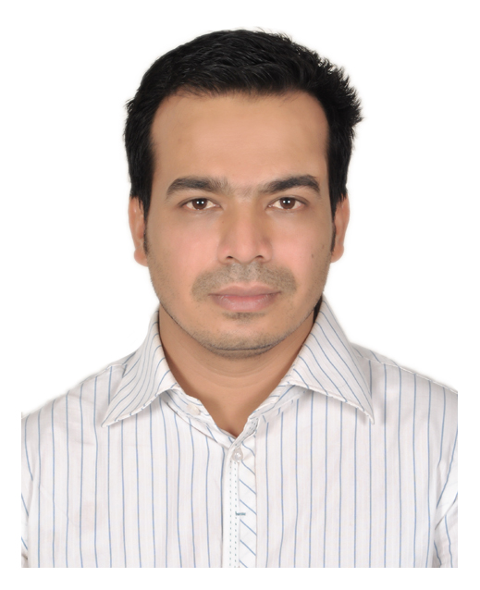
Abdul Ahad
Cell: 01711-080302
E-mail: ahad3346@gmail.com
Present Address: 5-NE2, Swapno Neer, Lake City Concord, Khilkhet, Dhaka

CAREER OBJECTIVE

Aspire to explore a challenging, growth oriented position for professional experiences as an employee and looking forward to working in an environment where there are opportunities for self-assessment and improvement in both individual and team based work that will be ultimately helpful for the organizational development.

WORKING EXPERIENCES

Union Group
(23rd July 2019- till now)

Working as “Channel Sales Manager” for mobile handset brand “REALME”
Working Location: Dhaka, Sylhet, Chottogram

Job Responsibilities:
- Lead nationwide sales team members to achieve sales targets
- Develop and implement effective sales strategies
- Monitor and analyze performance metrics and suggest improvements
- Prepare monthly, quarterly and annual sales forecasts
- Perform research and identify new potential customers and new market opportunities
- Liaison with Marketing and Product Development departments to ensure brand consistency

Micromax Informatics Ltd.
(23rd July 2018- 22nd July 2019)

Served as “Business Sales Manager” for mobile handset brand “MICROMAX”.
Working Location: Dhaka

Job Responsibilities:
- To take responsibility to achieve targets both-in Sales and Sale out
- Manage a big sales team and guide them in achieving individual as well as company goal.
- Provide market intelligence report to support business & strategic planning.
- Facilitate management team to review and evaluate business performance in business review meeting.

Khan Bahadur Group – ZTE Smart phone
(1st April 2017- 22nd July 2018)

Served as “National Sales Manager” for mobile handset brand “ZTE Smart Phones”

Job Responsibilities:
- Develop and implement effective sales strategies
- Lead nationwide sales team members to achieve sales targets
- Monitor and analyze performance metrics and suggest improvements
- Prepare monthly, quarterly and annual sales forecasts
- Perform research and identify new potential customers and new market opportunities
- Liaison with Marketing and Product Development departments to ensure brand consistency

Excel Telecom (Pvt) Ltd.
(1st March 2016- 31st March 2017)

Served as “Deputy National Sales Manager” for mobile handset brand “SAMSUNG”

Job Responsibilities:
- Set store wise value and volume target and ensure execution through involvement of stakeholders/partners.
- Review monthly Joint Business Plan (JBP) – Investment, ROI, Target, Promotional Activity etc.
- Find out right partner for sustainable business growth. Support and ensure Store expansion as per Monthly/Quarterly and yearly plan.
- Campaign Design – Trade Promotion, Consumer Promotion, Incentive for Sales forces
- Prepare catch up plan, forecasting and over all target management.

Excel Telecom (Pvt) Ltd.
(11th June 2012- 29th February 2016)

Served as “Regional Sales Manager – Regional Sales” for mobile handset brand “NOKIA”
Working Location: Mymenshing, Dhaka

Job Responsibilities:
- Lead & monitor all sales & service channels of regions attaining the required standard and regular market visits to ensure that teams are visiting markets regularly as per the yearly plan.
- Responsible for driving the regional business plan to achieve monthly, quarterly & yearly acquisition and revenue targets.
- Identify distribution gap of assigned region and build sustainable trade relationship with channel partners to establish control over trade.
- Liaison with central team for business development, running sales promotions, drive different development projects, identify and then minimize activity gaps.

Grameenphone Ltd.
(7th March 2007- 10th June 2012)

Served as “Territory Officer – Regional Sales”
Working Location: Mymenshing, Munshigonj, Dhaka

Job Responsibilities:
- Attain Territory Sales Target through daily POS visit, ensuring proper distribution of products and implementation of retail channel activities.
- Prepare own market visit plan, retail execution plan, TMM route plan, campaign execution plan, distribution extension opportunity etc. on regular basis.
- Monitoring all activities of the Distributor’s sales field force.
- Monitoring all the activities of other operators.
- Lead and motivate the retailers to strongly promote GP and induce push sales.
- Monitor SE and TMM performance on a regular basis and provide structured feedback for development.
- Achievement: Best Territory Officer for the year 2010.

A.K. Khan & Company Ltd. (Telecom Division), National Distributor of ROBI (Previously AKTEL)
(18th August 2005- 5th March 2007)

Served as an “Executive- Sales & Marketing”
Working Location: Chottogram

Job Responsibilities:
- Monitoring dealer activities to ensure adequate supply to every POS (Point of Sales).
- Make an area wise dynamic distribution plan.
- Visit area according to the Beat wise.
- To administrate and control the overall activities of the Officers & Dealer Sales Representative.
- Monitor the safety stock of the dealers.
- Frequently visit points of sales at field level.

Columbia Multi – TECH (JV) ltd.
(8th May 2001- 10th August 2005)

Served as an “Executive- Sales & Marketing”
Working Location: Chottogram

Job Responsibilities:
- Effective execution of company’s different promotional program.
- Identify and developing new markets.
- Implementation of company’s sales policy and planning.
- Taking feedback from customers about the quality of sold product.
- Achievement: National best Territory officer in q1 & q2, 2011.

ACADEMIC PROFILE

Examination Name | Institute | Major Subject | Completion Year | Result
M.B.A  (Masters of Business Administration) | International Islamic University Chittagong. | Finance | 2005 | 2.913
B.Com Hons.  (Bachelor Of Commerce) | National University | Accounting | 2000 | 2nd class
H.S.C  (Higher Secondary Certificate) | Haji A B College | Commerce | 1995 | 2nd Division
S.S.C  (School Secondary Certificate) | Cargill Govt. High School | Science | 1992 | 1st Division

Computer Proficiency:

  - Efficient in using basic Microsoft Office packages including Word, Excel, Power Point
  - Knowledge on Emailing, using Webmail and use of Internet.
  - Trained and skilled in ERP using.

PERSONAL INFORMATION:

  - Father’s Name : Abdul Gafur
  - Mother’s Name : Suriya Begum
  - Date of Birth : 30th Nov, 1978
  - Nationality : Bangladeshi
  - Marital Status : Married
  - Religion : Islam
  - Permanent Address : Noya Mazar, Bot Toli, PS: Bayzid Bostami, Kulgown, Chittagong
  - NID Number : 7310814558

REFERENCES:
Syed Ashraf Uddin Ahmed  Head 2.5 NVG Bangladesh  Essilor Bangladesh Private Limited  Mobile: 01618225329  E-mail: syed.a@essilor.com.bd | Darpan Kanti Roy  FVP & Head of Division  Mercantile Bank Ltd.  Mobile: 01819550551  E-mail: darpan@mblbd.com

